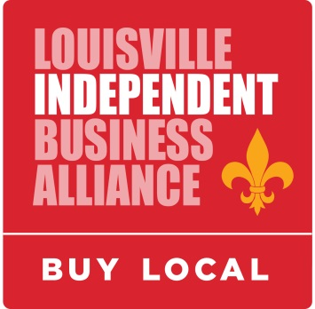

Louisville Local Business Expo
An all local and independent business showcase.

Thursday, January 19, 2017, 12n-1pm (LIBA member lunch), 1pm-4:30pm (Expo)
Mellwood Arts & Entertainment Center, Picasso Room, 1860 Mellwood Ave.
As LIBA members, we have all become more aware of the reasons to buy local – and they apply just as much to our business purchases as our personal ones. This event will give our members (and other business owners) the chance to ‘walk the talk’ and find quality, local vendors for their business purchases. After all, a market shift of just 10% to local independent businesses would retain an additional $416 million in our regional economy, which helps all of our businesses!

Last year was our very first all local Expo, and it was a smashing success. We heard from many businesses that they were very pleased with the event and plan to be part of it again this year. So sign up now – we expect to sell out of booth space!

Basics of the event:

- 10am-12n – Exhibitor booth set up
- 12n-1pm – LIBA Member Lunch – This will be the January member event for LIBA, which also serves as our annual meeting where our board elections are held. Always a popular meeting, and sure to start off the exhibiting day with a good crowd. (Meal is included with your booth/sponsorship fees.)
- 1pm-4:30pm – Exhibit area open to LIBA members and general public, free admission with business card
- 1pm-4:30pm – Various programs for small business education (announcements coming soon)

Sponsorship and exhibitors are limited to LIBA members only. Sponsorships and booth space are sure to fill up fast, so sign up now to guarantee a spot!

Sincerely,

The LIBA Business-To-Business Committee
GOLD SPONSOR - $2,000 (One available)

- Top billing with LIBA as the presenter of the event
- Sponsor logo to be included in all advance promotions
  - Large logo & link to company site on all social media/emails/electronic invitations
  - All press releases, advertising, signage and electronic communication
  - Large logo & link on event website
  - On the Facebook event banner picture
- Interview/Spotlight on Website, Facebook and Twitter
- Sponsor logo [as Presenting Sponsor] on Presentations Stage banner
- Sponsor logo [as Presenting Sponsor] on rotating slide show
- Sponsor logo [as Presenting Sponsor] on event program with highlighted listing and company description/offer
- Opportunity to be included in shared TV or radio segments [as opportunities permit]
- Opportunity to address attendees from the Presentation Stage
- Emcee introduction and acknowledgment throughout 5 hour event
- Opportunity for placement of 1 large onsite banners [Sponsor-provided]
- Main logo placement on goodie bag given to all attendees
- Opportunity to include item in goodie bag given to all attendees
- Category exclusivity within sponsors
- Two event booths (connected or separate - includes two 6’ tables and chairs) and 6 lunches
- 10% discount on next year’s sponsor fee

SILVER SPONSORS - $750 (Five available: 3 sold, 2 left)
- Sponsor logo to be included in all advance promotions
  - Logo & link to company site on all social media/emails/electronic invitations
  - Press releases, advertising, signage and electronic communication
  - Logo & link on event website
- Sponsor logo on Presentation Stage banner
- Sponsor logo on rotating slide show
- Sponsor logo on event program with highlighted listing and company description/offer
- Emcee introduction and acknowledgment throughout 5 hour event
- Name placement on goodie bag given to all attendees
- Opportunity to include item in goodie bag given to all attendees
- Category exclusivity within sponsors
- One event booth (6’ table and chairs included) and 4 lunches
- 10% discount on next year’s sponsor fee

BRONZE SPONSORS - $300
- Sponsor name to be included in all advance promotions
  - Name & link to company site on all social media/emails/electronic invitations
  - Advertising, signage and electronic communication
  - Event website
- Sponsor name on Main Stage banner
- Sponsor name on rotating slide show
- Sponsor name on event program with highlighted listing and company description/offer
- Emcee introduction and acknowledgment throughout 5 hour event
- Opportunity to include item in goodie bag given to all attendees
- One event booth (6’ table and chairs included) and two lunches
- 10% discount on next year’s sponsor fee

EXHIBITOR BOOTH - $75 (plus $25 deposit, refunded when booth remains set up until end of event)
- One event booth (6’ table and chairs included) and one lunch

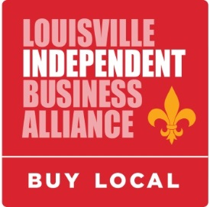

Louisville Local Business Expo
Thursday, January 19, 2017
Mellwood Arts & Entertainment Center, Picasso Room, 1860 Mellwood Ave.

Go to http://bit.ly/2h03P9k to sign up online, or send in the following:

Organization Name_____________________________________________________________________

Contact Person________________________________________________________________________

Address _____________________________________________________________________________

City ____________________________________ State ___________ Zip ________________________

Phone ____________________________ Email _____________________________________________

Level of participation:

Gold Sponsor ($2,000) Silver Sponsor ($750) Bronze Sponsor ($300)
Booth ($75) Additional Lunches ($10 each, exhibitors only):________

Electricity:

No electricity needed Please reserve a spot with access to electricity ($25)

Do you plan to have a giveway/raffle? (We’ll promote it in advance if so.)

Yes No Haven’t decided yet

Payment Method:

Check (enclosed, payable to LIBA)

Credit card number(Visa/MC/AMEX/Discover):_____________________________________________
Security Code:_______ Expiration Date:_______Signature:______________________________________

Please return your application by December 15, 2016 to:
Louisville Independent Business Alliance
Attn: Jennifer Rubenstein
PO Box 4759
Louisville, KY 40204
jennifer@keeplouisvilleweird.com
Cell: 502-500-4669
Fax: 502-327-1326

Or go to http://bit.ly/2h03P9k to sign up online.

